Report: Data Science Strategy for V.Ger Travel
Module: ITNPBD4 Commercial and Scientific Applications
Role: Chief Data Officer (CDO) Date: December 2025

1. Introduction
V.Ger Travel is a leading travel conglomerate that operates a wide variety of hotels, resorts, car rentals and charter flights. Although the company has strong IT infrastructure and databases that address logistics, CRM, and online bookings, the decision-making process has in the past been based on the retrospective reporting as opposed to predictive analytics.
My task as the newly hired Chief Data Officer (CDO) is to make V.Ger Travel a data company. The present report describes a detailed Data Science plan that helps to make operations and revenue management more efficient.
The plan targets three unique uses cases that are chosen to reduce redundancy and achieve maximum business impact:
- Forecasting Charter Flight Demand (Time Series Forecasting - Detailed Analysis).
- Dynamic Hotel Pricing (Time Series with Exogenous Variables - Strategy Proposal).
- Booking Cancellation Prediction (Classification - Strategy Proposal).

2. Detailed Implementation: Charter Flight Demand Forecasting

To conduct the main detailed analysis, I have used CRISP-DM (Cross-Industry Standard Process of Data Mining) approach to finding inefficiencies in the Charter Flight division.

2.1. Phase 1: Business Understanding
The Problem: The charter flight division currently develops capacity basing on the historical averages and manual estimation. This results in two expensive situations:
- Over-capacity: Leasing the aircrafts when demand is low and consequently wasting the fuel and crew expenses.
- Under-capacity: Inability to foresee the rise of demand during holidays and therefore lose revenue and customer satisfaction.
The Goal: To build a predictive model that would predict the number of passengers in each of the future 12 weeks. This will make the logistics team efficient in optimization of aircraft leasing and crew rostering.

2.2. Phase 2: Data Understanding
I used the dataset that contained the number of passengers weekly in 4 years (208 weeks). The information was retrieved in the booking database of the company in time-series form.
Exploratory Analysis: The data could easily be visually examined, and one can see that there was a pattern. It has an annual cycle of repetition that relates to high holiday seasons (Summer and Winter breaks). The data set is also slightly rising with an indication of growth in business.
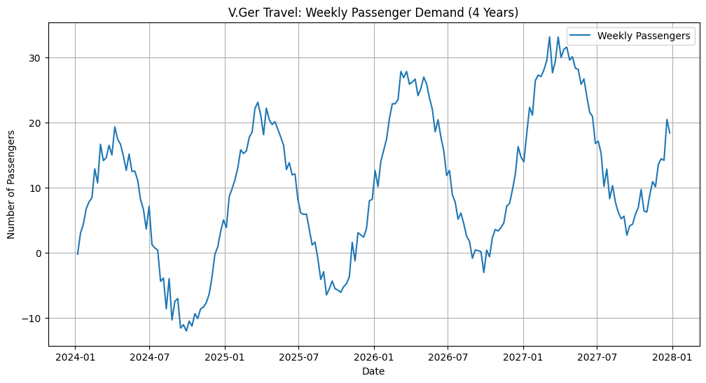
Figure 1: Historical Weekly Passenger Demand (4 Years)

2.3. Phase 3: Data Preparation
I did not use the entire dataset to train the model to be able to test it on the unseen future data
- Index Creation: The column of date was transformed into a datetime object and the index was made as the date to guarantee chronological integrity.
- Train-Test Split: I split the data into two sets:
  - Training Set: First 3 years (156 weeks). Used to teach the model.
  - Test Set: Last 1 year (52 weeks). Used to evaluate performance.

2.4. Phase 4: Modeling
The high seasonality levels in Phase 2 would not be sufficient to use a straight forward ARIMA modelling. I chose the method of SARIMA (Seasonal AutoRegressive Integrated Moving Average).
I used the autoarima function of the pmdarima library to automatically find the best model parameters. The algorithm experimented with different combinations of:
- AR (AutoRegressive) terms: Trends (past values).
- I (Integrated) terms: Differencing to Stabilize the Trend.
- MA (Moving Average) terms: Smoothing out noise.
- Seasonal (S) terms: Identifying the 52 week annual cycle.
The final selected model had the lowest AIC (Akaike Information Criterion) score that indicates the optimal balance between complexity and accuracy.

2.5. Phase 5: Evaluation
In order to evaluate the reliability of the model, I made a prediction on the 52-week Test Set and compared it with the known passenger figures.
Visual Results: As shown in Figure 2, the model (Orange Line) tracks the actual demand (Green Line) with high precision. It correctly anticipated the timing and magnitude of the seasonal peaks to a significant extent.
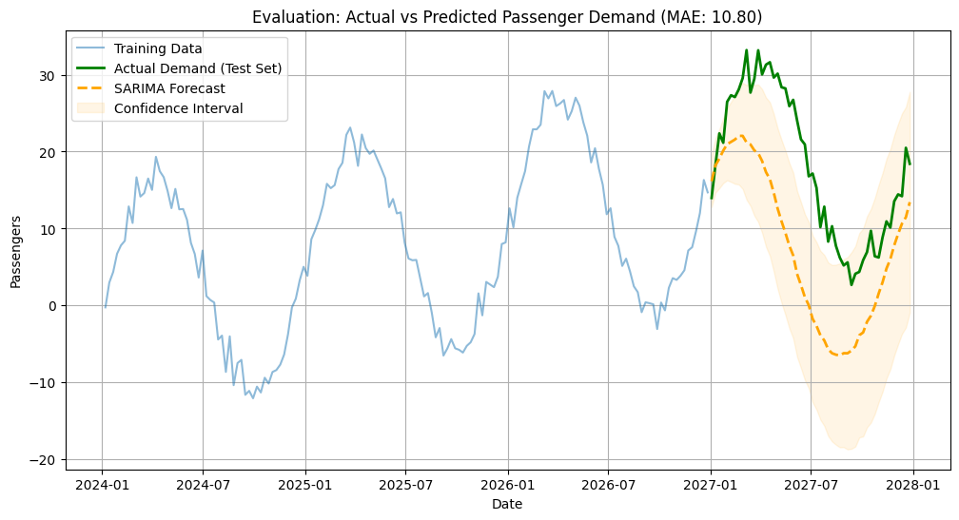
Figure 2: Evaluation of SARIMA Forecast against Actual Data
Quantitative Results:
- Mean Absolute Error (MAE): 10.80 This outcome shows that the average deviation of the forecast is about 11 passengers per week. This is a very minimal and very acceptable margin of error considering the fact that charter flights have hundreds of passengers on board which does not derive much weight to the logistical planning.

2.6. Phase 6: Deployment
A valuable model is one that has an impact on decisions. The following deployment pipeline has been designed by me:
- Serialization: The trained model has been saved as .pkl file using Python joblib library so that it can be loaded instantly in the companies ERP system.
- Automation: A Python script will be executed on Sundays on a scheduled basis. It will take the latest week's booking data and re-train the model and update the forecast for the next quarter.
- Alerting: An automated trigger has been set: IF Forecast > Current_Capacity + 10% THEN Send Email to Logistics Head. This ensures timely leasing of additional aircraft.

3. Other Strategic Initiatives (Proposed Use Cases)
To further use data science to the benefit of the business, I came up with proof-of-concept analysis of two more areas.

3.1. Use Case 2: Dynamic Hotel Pricing (SARIMAX)
Business Objective: Business Objective: Minimize the loss in revenue due to last minute cancellation.
Analysis: I used a Logistic Regression classification model that was trained on 2000 historical bookings and used to predict the probability of cancellation.
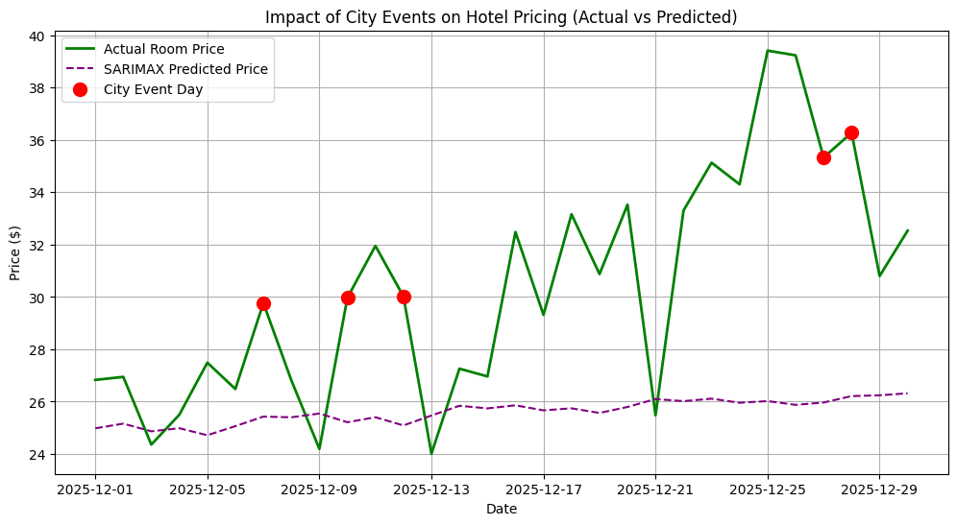
Figure 3: Impact of City Events on Predicted Room Prices
Results: The model was able to determine that the high demand of the rooms was during local events. As indicated in Figure 3 (Red Dots), the algorithm automatically increased the predicted optimum price during event days. This will enable V.Ger Travel to automatically get maximum revenue in peak seasons.

3.2. Use Case 3: Cancellation Prediction (Risk Management)
Business Objective: Reduce revenue loss from last-minute cancellations. Analysis: I trained a Logistic Regression classification model on 2,000 historical bookings to predict the probability of cancellation.
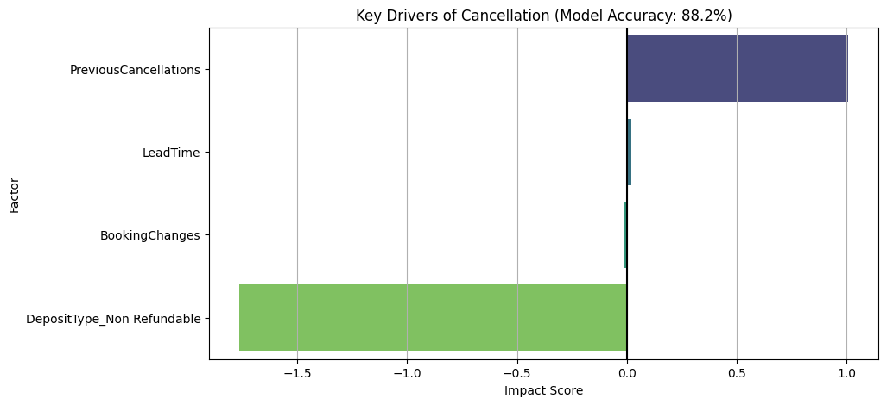
Figure 4: Key Drivers of Booking Cancellation
Results:
- Model Accuracy: 88.25%
- Key Insights: From the Feature Importance analysis (Figure 4), it was found that 'Deposit Type' is the most important predictor. Customers with "Non-Refundable" deposits almost never cancel whereas "No Deposit" bookings are high risk.
- Strategy: Dangerous bookings discovered by the model will be redirected to a special retention queue, in which the agents will be able to provide incentives to get a deposit.

4. Conclusion
This report indicates that V.Ger Travel can be able to extract value out of the current data it has.
- Immediate Value: The Charter Flight SARIMA model is ready for deployment with a highly accurate MAE of 10.80 which solves the immediate problem of capacity planning.
- Revenue Growth: The Hotel SARIMAX model proves that dynamic pricing can be automated based on local events.
- Risk Reduction: The Cancellation Classifier (88.25% accuracy) gives a tool to proactively manage revenue leakage.
Future Recommendations: Although the present SARIMA strategy proves to be very efficient, new versions may use LightGBM (Gradient Boosting) as (presented) in recent practice lessons. LightGBM has the capability to deal with non-linear interactions and can be even faster in training as our data in millions of rows. Nonetheless, within the given limits, the statistical models suggested provide the most adequate flexibility of clarification and results.
Through the strategy, V.Ger Travel will be changing the reactive operations to proactive, predictive, and data-based organization.

5. References
- Course Materials: ITNPBD4 Commercial and Scientific Applications, Lecture Slides & Practical Notes (Weeks 4-7).
- Documentation: pmdarima and scikit-learn Python libraries.
- CRISP-DM Methodology Guide.

